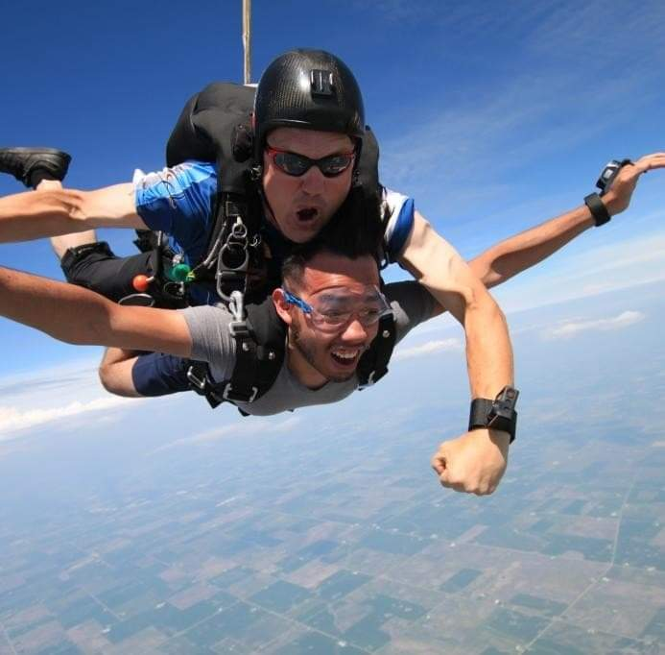Hi! My name is Andy Garcia, and my major is computer science. My plan after graduation is land a job as an entry level software engineer and work my way up to a senior software engineer. The reason why I’m taking CSC 4500 is because it’s a requirement for my major and I’m a bit curious how companies collect, store and retrieve information about me and everyone else since they get tons of raw data every second.

My non career ambitions are to get into real-estate so I can either retire early or work part-time as a software engineer so I can have more time for my other hobbies such as eventually trains so I can enter a weight-lifting competition and do other hobbies such as skydiving, paintballing and more physical sports. I’m not part of any organization through AU, but I do work part-time at a telecommunications company as a sales representative which helps keeping me from having to take on student loans and do other hobbies since my family doesn’t come from an affluent/middle class background, so it’s up to me to help them out and fund my own hobbies.

Other things about me:

I was raised and still live with my mom, uncle, and younger brother in West Chicago (it’s a small town by St. Charles) and I commute to AU. I don’t watch a lot of movies or tv shoes, I prefer more of an active lifestyle where my mind and body is always engaged, such as weightlifting, skydiving, paintballing, and motorcycle riding. But when my body is aching and want to watch something, I usually watch some anime, Star Wars, or some action/super-hero movie. I also have started a linking to traveling. Before the pandemic, my friends and I went out to St. Louis, Missouri for 3 days and explored the city. Honestly it felt a little bit like Chicago, but it did feel different. We were going to go travel the southwest (minus California) but when the pandemic happened, that trip got scrapped. It was unfortunate since that was going to be my second time going out-of-state. Hopefully this pandemic situation gets cleared and we go back to normal, but I have a feeling this is going to be a while.

My favorite type of food is Mexican cuisine. Some of my favorite dishes are enchiladas, tacos, tortas, and catfish with a side of rice and beans with tons of tortillas. I also like to eat anything with meat (sorry if you’re a vegetarian), such as burgers, chicken sandwiches/tenders, fish, and maybe a little bit of pork, like chorizo. I follow the saying, got to eat big to get big.

Since I live in a Mexican household, I only speak Spanish at home/work and English everywhere else. My younger brother can write and understand Japanese, and he’s currently working on speaking it.

I mostly listen to rap/reggaeton when I’m out an about. Reggaeton is basically Spanish rap by the way. When I’m working out, I tend to listen to pop/rock since those types of genres are more dynamic and give me focus to pump out those last few reps at the end of my set.